AMRUTVAHINI COLLEGE OF ENGINEERING, SANGAMNER

DEPARTMENT OF COMPUTER ENGINEERING

2023-2024

LP-VI Mini Project report (BI)

# on

‘PowerBI Dashboard: Sales Performance Analysis’



# BE Computer Engineering BY

Mr. Gaurav Bhima Chaudhari(4117) Mr. Harsh Sunil Chhajed(4118) **Guided by** – Dr. R. G. Tambe

* **Title:** Empowering Decision-Making Through Data: PowerBI Dashboard for Comprehensive Sales Performance Analysis.
* **Problem Definition and Data Mining Task Identification:**

The objective of this Business Intelligence (BI) mini-project is to analyze sales data and derive actionable insights to improve business performance. The identified data mining task for this project is sales forecasting and analysis. By analyzing historical sales data, we aim to predict future sales trends, identify factors influencing sales performance, and optimize business strategies accordingly.

* **Standard Data Mining Dataset:**

For this project, we will utilize a standard dataset containing sales transaction records. The dataset includes various attributes such as order details, customer information, product categories, sales dates, and geographical information. Each record represents a unique sales transaction, allowing for comprehensive analysis of sales patterns and trends.

* **Data Preparation and Cleaning:**

Before proceeding with the analysis, the dataset will undergo data preparation and cleaning processes. This involves tasks such as:

* Handling missing or erroneous data entries
* Standardizing data formats and units
* Removing duplicate records
* Encoding categorical variables
* Feature engineering, if necessary
* **Dashboard Overview and Updates:**

The dashboard has undergone several enhancements to provide a more comprehensive view of key performance indicators across different regions and categories. The following updates have been implemented:

* **Regional Performance:**

The values for the Central, East, South, and West regions have been modified to reflect the latest data and trends.

* **Metrics Overview:**
* Sales by Payment Mode
* Orders
* Sales
* Profit
* Ship Days
* Sales by Region
* Sales by Month
* Sales by Ship Mode
* Sales by Segment
* Profit by Month
* Sales Category
* Sales by Subcategory
* Profit and Sales by State Map

These metrics offer a detailed analysis of sales performance, profitability, and operational efficiency across different dimensions, enabling more informed decision-making and strategic planning.

* **Dashboard Design and Visualization:**

In the Power BI project, we will import the cleaned dataset and design a comprehensive dashboard for visualizing key insights. The dashboard will include:

* **Sales Overview:**

Visual representation of total sales revenue, profit margins, and sales trends over time.

* **Product Analysis:**

Charts and graphs showcasing top-selling products, product categories, and their respective contribution to overall sales.

* **Customer Segmentation:**

Analysis of customer demographics, purchase behavior, and segmentation based on various criteria such as location, industry, or purchase frequency.

* **Forecasting:**

Utilization of advanced forecasting models to predict future sales trends and identify potential opportunities or risks.

* **Geospatial Analysis:**

Maps and geographical visualizations depicting sales distribution across different regions and territories.

* **Filters, Slicers, and Interactivity:**

The dashboard will incorporate interactive features such as filters and slicers to allow users to dynamically explore the data. Users can filter data based on specific time periods, product categories, customer segments, or geographical regions to gain deeper insights and make informed decisions.

* **Export and Insights:**

The finalized dashboard will be exportable as a PDF document for easy sharing and distribution among stakeholders. Additionally, the project will provide valuable insights and actionable recommendations based on the analysis conducted, empowering businesses to optimize their sales strategies, improve operational efficiency, and drive sustainable growth.

* **Project Learnings:**

Throughout the project, students will gain hands-on experience in:

* Data cleaning and preparation techniques
* Dashboard design principles and data visualization best practices
* Utilization of advanced Power BI features such as forecasting and geospatial analysis
* Interpretation of analytical insights and their application in real-world business scenarios
* By actively engaging in this BI mini-project, students will develop valuable skills that are highly relevant in the field of data analytics and business intelligence.
* **Results:**
* **Dataset CSV File:**

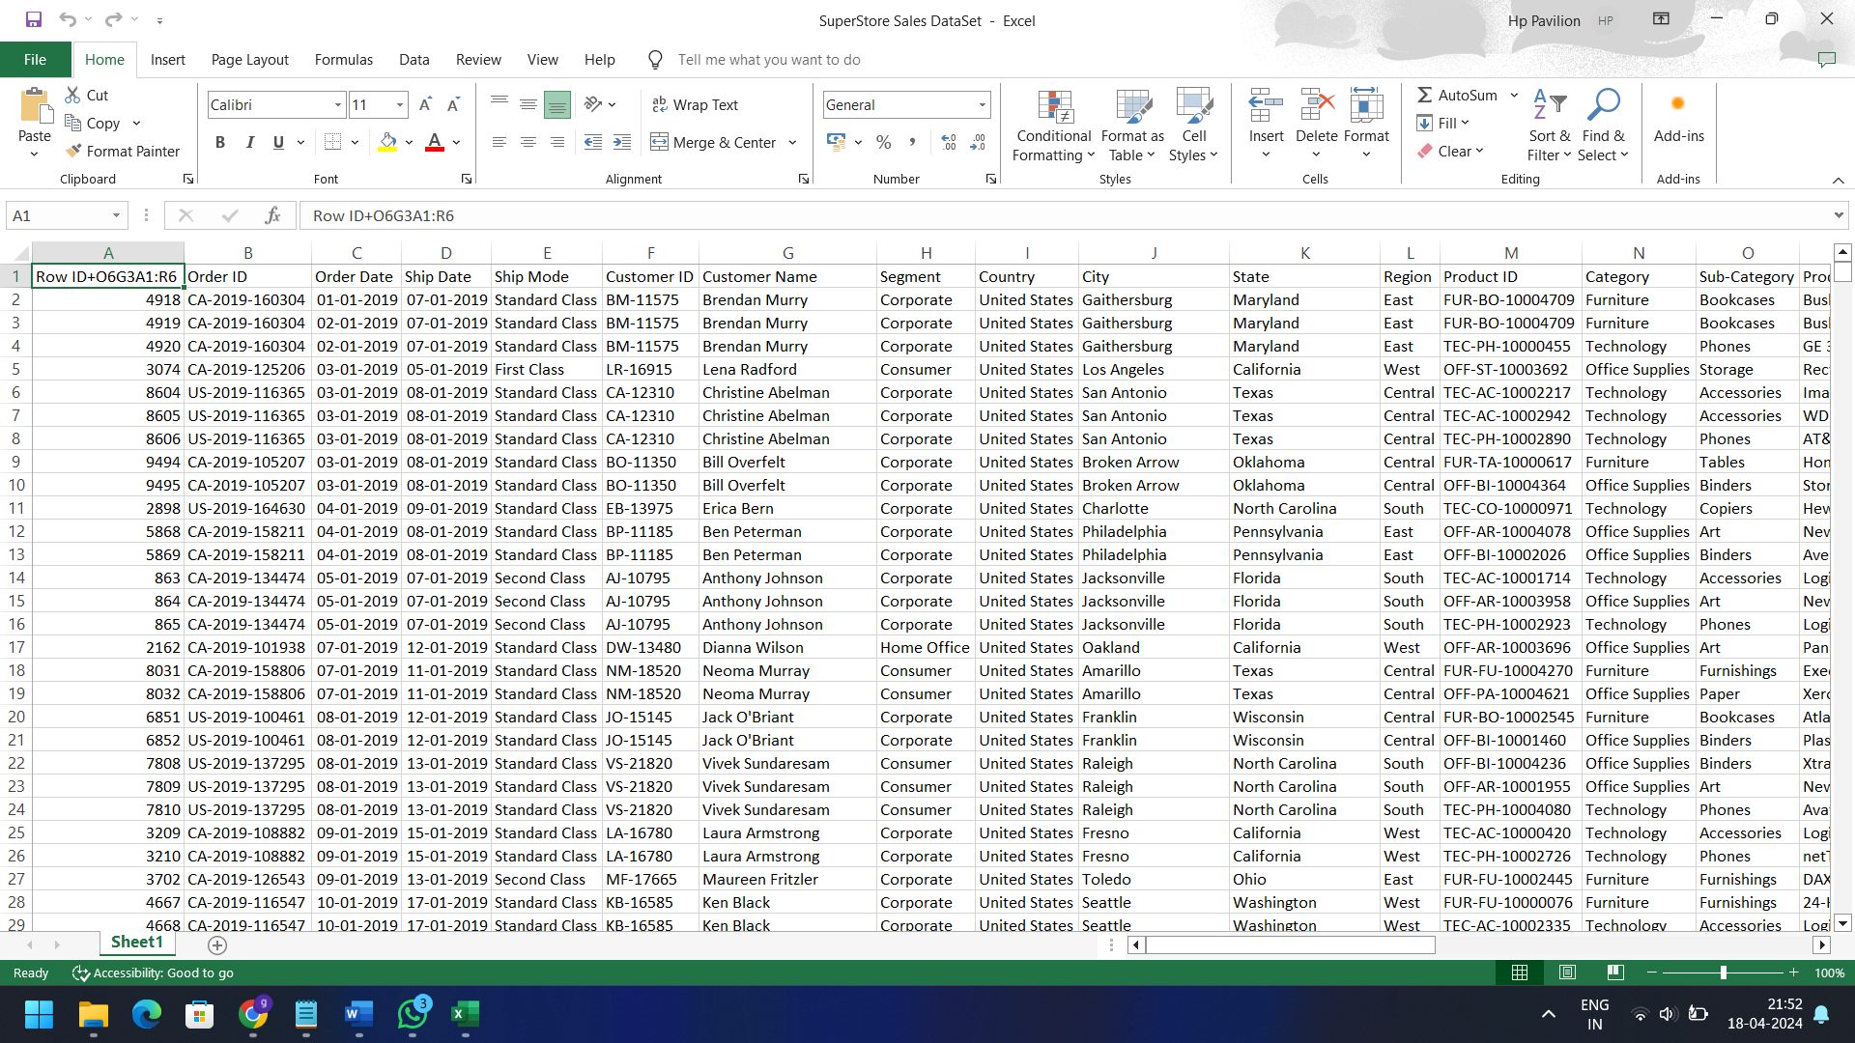

* **Dashboard:**

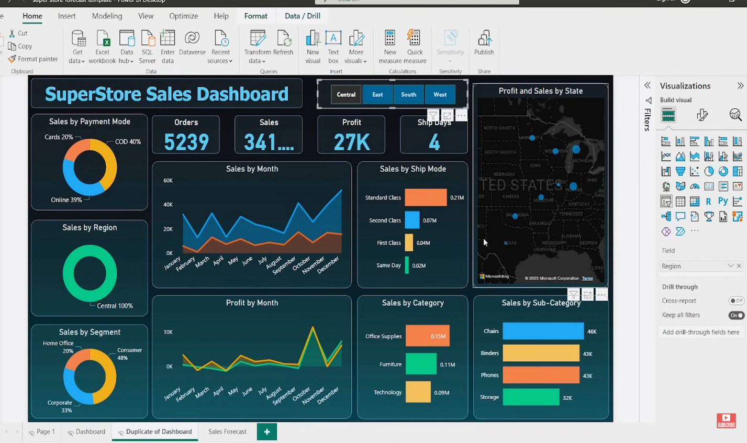

* **Forecasting:**

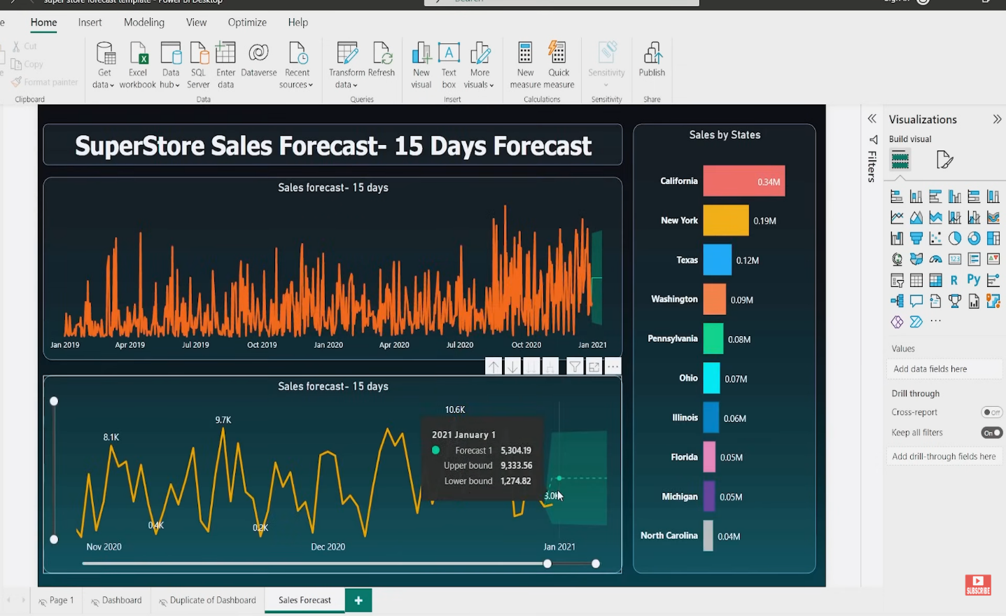

* **Conclusion:**

"PowerBI Dashboard: Sales Performance Analysis" project has successfully utilized advanced data analytics techniques to provide a comprehensive view of sales performance metrics. Through the creation of an interactive dashboard, stakeholders can now easily visualize and interpret key indicators such as sales revenue, profit margins, and regional performance. By leveraging these insights, businesses can make informed decisions, optimize sales strategies, and drive sustainable growth. Additionally, the project has facilitated valuable learning experiences for students, equipping them with practical skills in data analysis, visualization, and interpretation that are essential in today's data-driven business environment.